Spark RDD VS Dataframe VS Dataset

Name : -
NIM : -

Spark RDD

What is RDD?
Resilient Distributed Datasets (RDDs) are the fundamental data structures of Apache Spark. Introduced in Spark's early versions, RDDs provide a fault-tolerant, distributed collection of elements that can be processed in parallel across a cluster. They enable efficient data processing by leveraging in-memory computation and are designed to handle both batch and streaming data.

Key Features of RDD
Key Features of RDDs
- Immutable: Once created, RDDs cannot be altered. Transformations on RDDs produce new RDDs.
- Distributed: Data is partitioned across multiple nodes in a cluster, allowing parallel processing.
- Fault-Tolerant: RDDs track the lineage of transformations, enabling automatic recovery from failures.
- Lazy Evaluation: Transformations are not executed immediately. They are evaluated only when an action is called.
- In-Memory Computation: RDDs can cache data in memory, speeding up iterative algorithms.

Creating and Using RDD

Creating RDD
RDD can be created using 2 methods, which are:
- From existing collection: 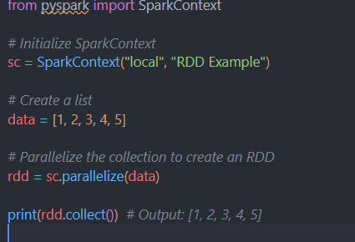
The code above create a rdd based on the list of 1, 2, 3, 4,5 given.
- From external data source: 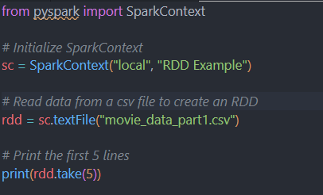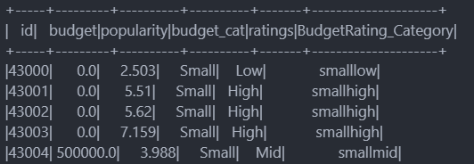

Basic RDD Operation
RDD operations are categorized into transformations and actions.
- Transformations: Operations that create a new RDD from an existing one (e.g., map, filter).
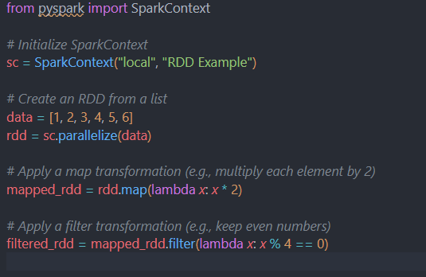
- Actions: Operations that trigger computation and return results (e.g., collect, count).
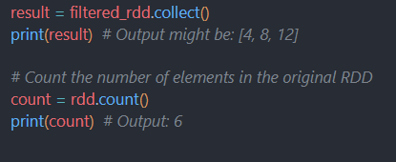

When to Use RDD
- Low-Level Transformations: When you need fine-grained control over data manipulation.
- Complex Operations: Operations that are not easily expressed with higher-level APIs.
- Functional Programming: Leveraging the full power of functional transformations.
- Legacy Code: Integrating with existing codebases that use RDDs.

Spark Dataframe

What is it?
A DataFrame in Apache Spark is a distributed collection of data organized into named columns, similar to a table in a relational database or a DataFrame in Python's pandas library. Spark DataFrames provide higher-level abstractions compared to Resilient Distributed Datasets (RDDs), offering optimization features such as Catalyst Optimizer for query planning and Tungsten Execution Engine for better memory management and execution.
DataFrames are built on top of RDDs but are more efficient and user-friendly, making them ideal for structured data processing tasks.

Key Features
Key Features of Spark DataFrames
- Distributed and Immutable: Like RDDs, DataFrames are distributed across nodes and immutable.
- Schema-based: They allow operations on named columns, making them easier to work with.
- Optimized: Spark’s Catalyst optimizer automatically optimizes query execution plans, making DataFrame operations efficient.
- Lazy Evaluation: Similar to RDDs, DataFrame operations are lazily evaluated.
- Compatibility: You can load DataFrames from multiple data sources like JSON, Parquet, ORC, Hive, and SQL databases.

Creating and Using Spark Dataframe

Creating a Spark Dataframe
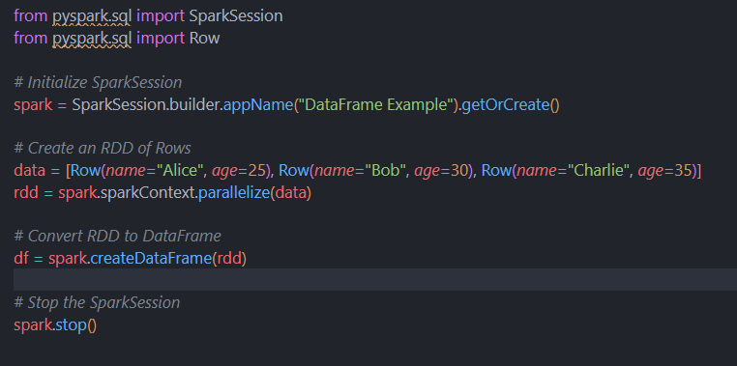

Basic Operation of Spark Dataframe
- Printing Dataframe
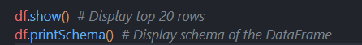
- Filtering Data
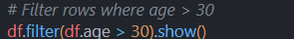
- Subsetting Columns
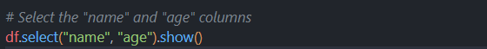

When to use Spark Dataframe
DataFrames are ideal for most data processing tasks, especially when working with structured data. They are:
- Optimized for performance via the Catalyst optimizer.
- Easier to use because of schema-awareness and named columns.
- Compatible with various data sources (CSV, JSON, Parquet, etc.).

Spark Dataset

What is It?
A Dataset in Apache Spark is a distributed collection of data that combines the best features of RDDs (Resilient Distributed Datasets) and DataFrames. It provides the strong typing and functional programming abilities of RDDs, along with the optimization benefits of DataFrames via the Catalyst optimizer. Datasets are available in Scala and Java, but in Python, Spark only supports DataFrames, which behave similarly to Datasets but are not type-safe.

Key Features
Key Features of Datasets
- Strongly Typed: Unlike DataFrames, which are essentially untyped (they operate on Row objects), Datasets are type-safe, meaning that the compiler can check the type of each element.
- Optimized: Datasets inherit the optimizations available in DataFrames, such as query planning via Catalyst and execution planning via the Tungsten engine.
- Distributed: Like RDDs and DataFrames, Datasets are distributed collections, processed in parallel across a cluster.
- Functional Programming API: Datasets offer functional transformations such as map, filter, flatMap, and others, similar to RDDs.

Creating and Using Spark Dataset

Creating a Spark Dataset from CSV file
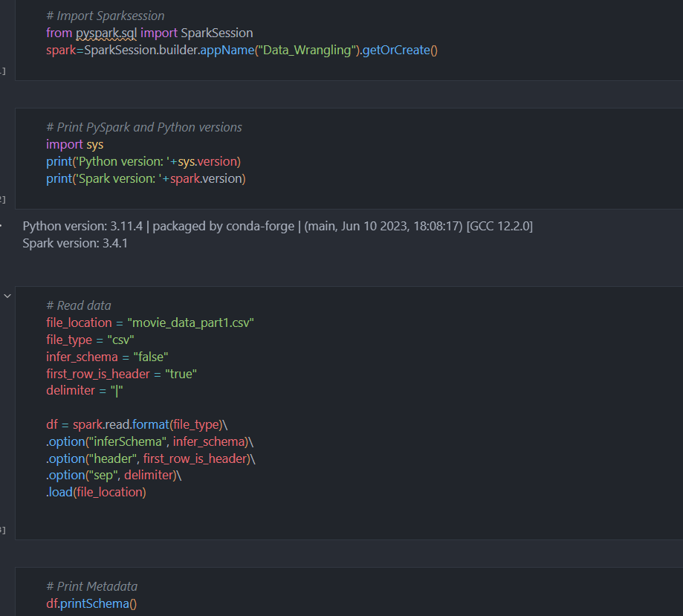

Basic use of Spark Dataset
- Print Metadata
- Counting
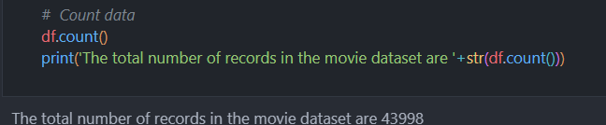
- Dropping Columns
- Subsetting Columns
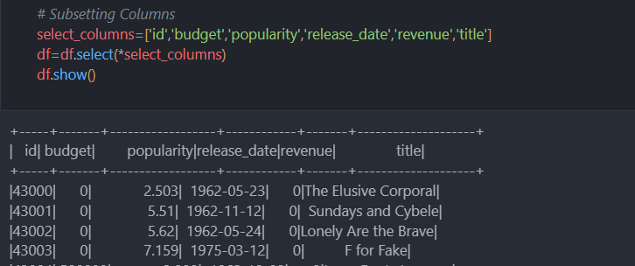

When to use Spark Dataset
Datasets offer a middle ground between the low-level control of RDDs and the high-level optimizations of DataFrames. They are ideal in scenarios where:
- Type safety is required, meaning compile-time checks are needed for schema and type correctness.
- Functional programming is beneficial, as Datasets provide full support for Scala’s functional operations.
- Optimization is needed, as Datasets leverage Spark’s Catalyst optimizer for query optimization.

Difference between Spark RDD, Dataframes, and Dataset
Feature/Aspect | RDD (Resilient Distributed Dataset) | DataFrame | Dataset
Definition | A low-level distributed collection of objects. | A distributed collection of data organized into named columns, like a table. | A distributed collection of strongly-typed objects, combining RDDs' functional API with DataFrames' optimization.
Data Structure | Distributed collection of elements (no schema). | Distributed collection of rows with named columns (schema). | Distributed collection of typed objects with schema.
Language Support | Available in Scala, Java, Python, and R. | Available in Scala, Java, Python, and R. | Available in Scala and Java (not Python).
Type Safety | No type safety. | No type safety (internally works with untyped Row objects). | Strongly typed (compile-time type safety with case classes).
Optimization | No built-in optimization. | Optimized using Catalyst and Tungsten engines. | Optimized using Catalyst and Tungsten, like DataFrames.
API Level | Low-level (requires more manual work). | High-level (provides SQL-like operations). | Combines high-level and low-level APIs with type safety.
Schema | No schema, each element is just a record of objects. | Has a defined schema for named columns. | Has a defined schema, but the schema is mapped to strongly typed objects.
Transformations | Supports functional transformations like map(), filter(), flatMap(). | Supports SQL-like and declarative transformations (select(), groupBy()). | Supports both functional transformations and SQL-like operations.
Lazy Evaluation | Yes, transformations are lazily evaluated. | Yes, transformations are lazily evaluated. | Yes, transformations are lazily evaluated.
Serialization | Uses Java serialization (or Kryo for better performance). | Uses optimized Spark SQL’s off-heap storage (Tungsten). | Uses optimized Spark SQL’s off-heap storage (Tungsten) with serialization of typed objects.
Action Methods | Examples: collect(), count(), reduce(). | Examples: show(), collect(), count(). | Examples: show(), collect(), count() (similar to DataFrame but with type safety).
Ease of Use | Requires more work for defining schema, transformations, and actions. | Easier to use with high-level SQL-like API. | Combines ease of use with type safety and better control.
Performance | Comparatively slower without optimizations. | Faster with query optimization and code generation. | Faster with query optimization and code generation, like DataFrames.
Best Use Cases | Low-level transformations, unstructured data, and complex data pipelines. | Structured data processing with well-known schema, large-scale SQL-like queries. | Structured and semi-structured data, with type safety, where compile-time checking and optimization are needed

Conclusion
In Apache Spark, RDDs, DataFrames, and Datasets offer different levels of abstraction and control for processing large-scale data:
- RDDs provide low-level control and flexibility with a functional programming approach but lack automatic optimizations. They are suitable for unstructured data and complex transformations, though they come with a performance cost.
- DataFrames introduce a high-level API for working with structured data, offering SQL-like operations and benefiting from Spark's Catalyst optimizer and Tungsten execution engine. They are ideal for working with large-scale structured data and provide significant performance improvements over RDDs.
- Datasets combine the best of both worlds: the functional, type-safe programming model of RDDs with the optimizations of DataFrames. Available in Scala and Java, they are a powerful choice when type safety is needed along with performance optimizations.
For most modern use cases, DataFrames are preferred due to their ease of use and optimizations, especially in Python. Datasets offer additional value in Scala and Java when you need strong type safety and more control over your data transformations. RDDs, while still useful in specific cases, are less commonly used due to their lack of built-in optimizations compared to DataFrames and Datasets.

Reference
https://spark.apache.org/docs/latest/api/scala/org/apache/spark/sql/Dataset.html
https://spark.apache.org/docs/latest/sql-programming-guide.html
https://spark.apache.org/docs/latest/api/python/index.html
https://spark.apache.org/docs/latest/rdd-programming-guide.html#transformations
https://spark.apache.org/docs/latest/api/python/pyspark.sql.html

